|  |  |
| --- | --- |
| **DATE** | **17/06/2023** |
| **TEAM ID** | **NM2023TMID06896** |
| **CODE** | **PYTHON** |

# AI ENABLED CAR PARKING SYSTEM

An AI-enabled car parking system is a solution that leverages artificial intelligence to automate and optimize the process of parking vehicles in a parking lot or garage. The system uses sensors, cameras, and other technologies to monitor and analyze the available parking spaces, detect the presence of vehicles, and guide drivers to vacant spots.

The problem that this system aims to solve is the inefficiency and frustration associated with traditional parking systems, which often result in wasted time, fuel, and resources. Conventional parking lots and garages typically rely on manual processes and human attendants to manage the flow of vehicles, which can be slow, error-prone, and prone to congestion.

An AI-enabled car parking system can address these issues by providing real-time information on available parking spots, optimizing the use of space, and minimizing the time and effort required for parking. This can improve the overall customer experience, reduce traffic congestion and emissions, and increase revenue for parking lot operators.

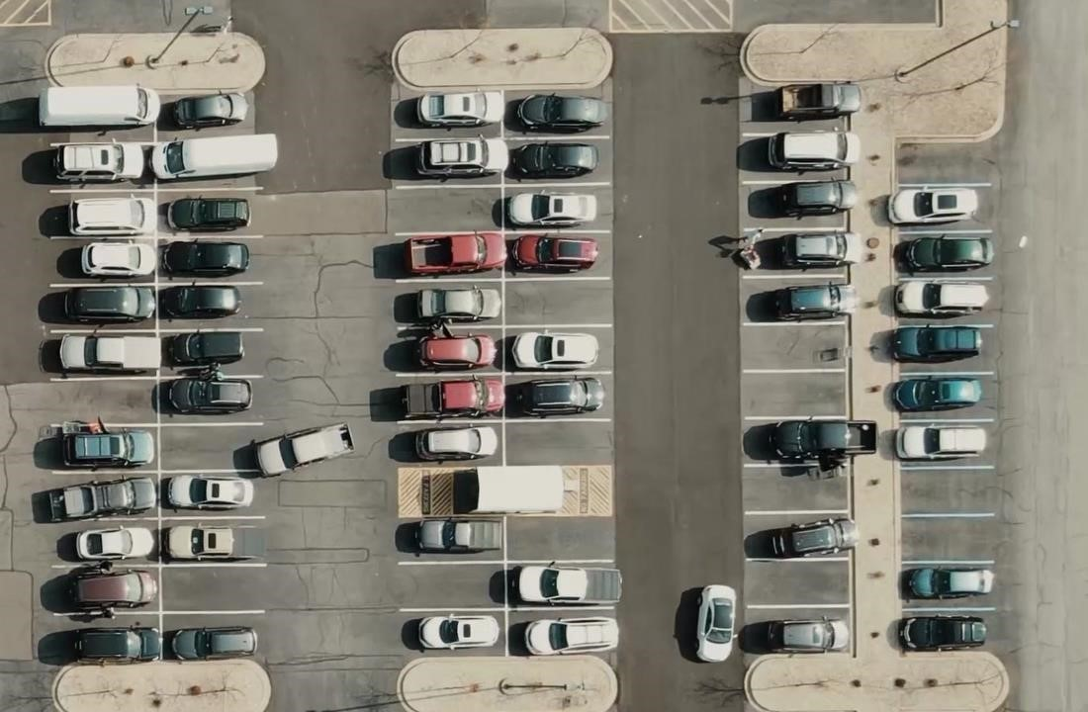

# MAIN.PY

import cv2 import

pickle

width, height = 107, 48

try: with open('CarParkPos', 'rb') as f: posList = pickle.load(f) except: posList = []

def mouseClick(events, x, y, flags, params): if events == cv2.EVENT_LBUTTONDOWN:

posList.append((x, y)) if events == cv2.EVENT_RBUTTONDOWN: for i, pos in enumerate(posList):

x1, y1 = pos if x1 < x < x1 + width and

y1 < y < y1 + height:

posList.pop(i)

with open('CarParkPos', 'wb') as f:

pickle.dump(posList, f)

while True:

img = cv2.imread('carParkImg.png')

for pos in posList:

cv2.rectangle(img, pos, (pos[0] + width, pos[1] + height), (255, 0, 255), 2)

cv2.imshow("Image", img)

cv2.setMouseCallback("Image", mouseClick)

cv2.waitKey(1)

## OUTPUT FOR MAIN.PY

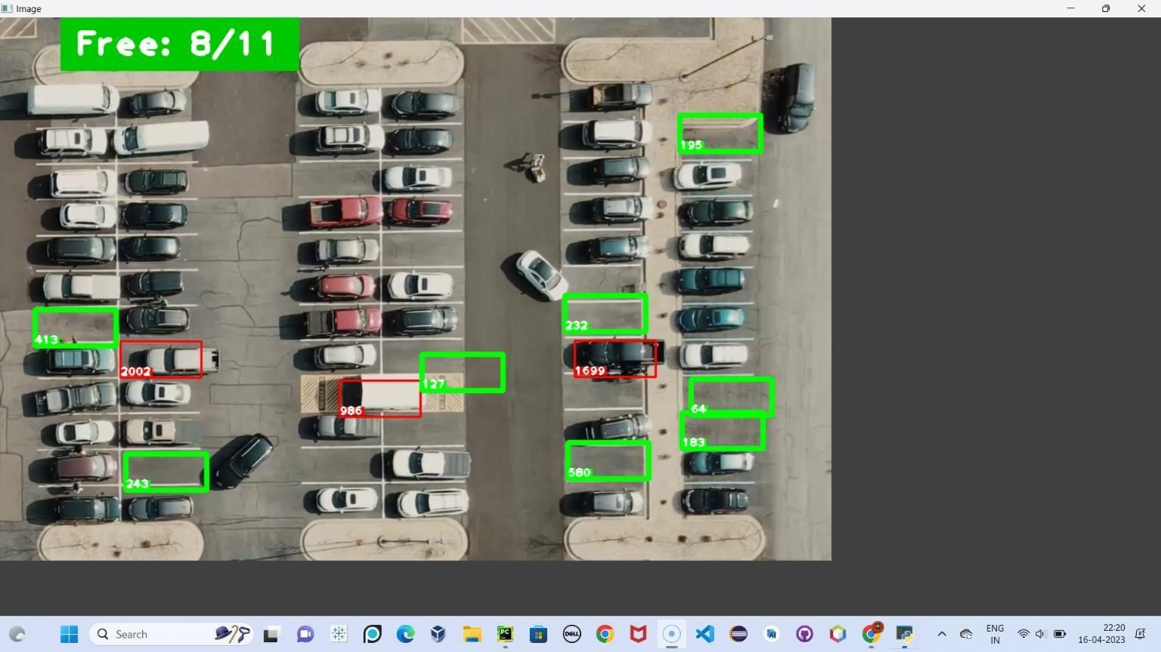

## Main_Trackbars.py

import cv2 import pickle import cvzone import numpy as np

cap = cv2.VideoCapture('carPark.mp4') width, height = 103, 43 with open('polygons', 'rb') as f: posList = pickle.load(f)

def empty(a):

pass

cv2.namedWindow("Vals") cv2.resizeWindow("Vals", 640, 240) cv2.createTrackbar("Val1", "Vals", 25, 50, empty) cv2.createTrackbar("Val2", "Vals", 16, 50, empty) cv2.createTrackbar("Val3", "Vals", 5, 50, empty)

def checkSpaces():

spaces = 0 for

pos in posList:

x, y = pos w, h

= width, height

imgCrop = imgThres[y:y + h, x:x + w]

count = cv2.countNonZero(imgCrop)

if count < 900: color = (0, 200, 0)

thic = 5 spaces

+= 1

else:

color = (0, 0, 200)

thic = 2

cv2.rectangle(img, (x, y), (x + w, y + h), color, thic)

cv2.putText(img, str(cv2.countNonZero(imgCrop)), (x, y + h - 6),

cv2.FONT_HERSHEY_PLAIN, 1,

color, 2)

cvzone.putTextRect(img, f'Free: {spaces}/{len(posList)}', (50, 60), thickness=3,

offset=20,

colorR=(0, 200, 0))

while True:

# Get image frame success, img = cap.read()

if cap.get(cv2.CAP_PROP_POS_FRAMES) == cap.get(cv2.CAP_PROP_FRAME_COUNT): cap.set(cv2.CAP_PROP_POS_FRAMES, 0) # img = cv2.imread('img.png')

imgGray = cv2.cvtColor(img, cv2.COLOR_BGR2GRAY)

imgBlur = cv2.GaussianBlur(imgGray, (3, 3), 1)

# ret, imgThres = cv2.threshold(imgBlur, 150, 255, cv2.THRESH_BINARY)

val1 = cv2.getTrackbarPos("Val1", "Vals") val2 = cv2.getTrackbarPos("Val2", "Vals") val3 = cv2.getTrackbarPos("Val3", "Vals") if val1 % 2 == 0: val1 += 1 if val3 % 2 ==

0: val3 += 1 imgThres = cv2.adaptiveThreshold(imgBlur, 255, cv2.ADAPTIVE_THRESH_GAUSSIAN_C,

cv2.THRESH_BINARY_INV, val1, val2)

imgThres = cv2.medianBlur(imgThres, val3) kernel = np.ones((3, 3), np.uint8)

imgThres = cv2.dilate(imgThres, kernel, iterations=1)

checkSpaces()

# Display Output

cv2.imshow("Image", img)

# cv2.imshow("ImageGray", imgThres) # cv2.imshow("ImageBlur", imgBlur) key = cv2.waitKey(1) if key == ord('r'): pass

**Output For Main_Trackbars.py**

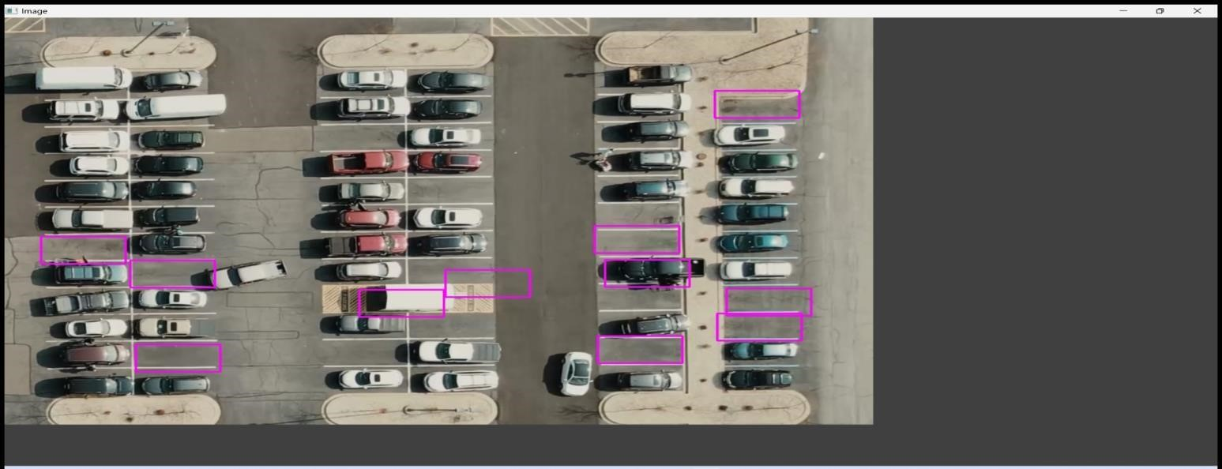

## ParkingSpacePicker.py

import cv2 import pickle import cvzone import numpy as np

# Video feed

cap = cv2.VideoCapture('carPark.mp4')

with open('CarParkPos', 'rb') as f:

posList = pickle.load(f)

width, height = 107, 48 def checkParkingSpace(imgPro):

spaceCounter = 0 for pos in posList: x, y = pos

imgCrop = imgPro[y:y + height, x:x + width] # cv2.imshow(str(x * y), imgCrop) count = cv2.countNonZero(imgCrop) if count <

900: color = (0, 255, 0) thickness = 5 spaceCounter += 1 else:

color = (0, 0, 255) thickness = 2 cv2.rectangle(img, pos, (pos[0] + width, pos[1] + height), color, thickness)

cvzone.putTextRect(img, str(count), (x, y + height - 3), scale=1, thickness=2, offset=0, colorR=color)

cvzone.putTextRect(img, f'Free: {spaceCounter}/{len(posList)}', (100, 50),

scale=3,

thickness=5, offset=20, colorR=(0,200,0)) while True:

if cap.get(cv2.CAP_PROP_POS_FRAMES) ==

cap.get(cv2.CAP_PROP_FRAME_COUNT):

cap.set(cv2.CAP_PROP_POS_FRAMES, 0) success, img = cap.read()

imgGray = cv2.cvtColor(img, cv2.COLOR_BGR2GRAY)

imgBlur = cv2.GaussianBlur(imgGray, (3, 3), 1)

imgThreshold = cv2.adaptiveThreshold(imgBlur, 255, cv2.ADAPTIVE_THRESH_GAUSSIAN_C,

cv2.THRESH_BINARY_INV, 25, 16) imgMedian = cv2.medianBlur(imgThreshold, 5) kernel

= np.ones((3, 3), np.uint8) imgDilate = cv2.dilate(imgMedian, kernel, iterations=1)

checkParkingSpace(imgDilate)

cv2.imshow("Image", img)

# cv2.imshow("ImageBlur", imgBlur) # cv2.imshow("ImageThres", imgMedian) cv2.waitKey(10)

## OUTPUT FOR CARPARKLMG.PNY



